Chapter 6 | Abstract  This chapter covers advanced Express.js concepts like file upload using Multer, dynamic templates with EJS, and email functionality using Nodemailer.

Multer
Multer is a node.js middleware for handling multipart/form-data, which is primarily used for uploading files. Multer adds a file or files object to the request object. The file or files object contains the data of files uploaded via the form.

Installation
npm install multer

File information
Each file contains the following information:
Key | Description
fieldname | Field name specified in the form
originalname | Name of the file on the user’s computer
encoding | Encoding type of the file
mimetype | Mime type of the file
size | Size of the file in bytes
destination | The folder to which the file has been saved
filename | The name of the file within the destination
path | The full path to the uploaded file

Storage(DiskStorage)
- The disk storage engine gives you full control on storing files to disk.
- There are two options available, destination and filename. They are both functions that determine where the file should be stored.
  - destination is used to determine within which folder the uploaded files should be stored. This can also be given as a string (e.g. '/tmp/uploads'). If no destination is given, the operating system’s default directory for temporary files is used.
  - filename is used to determine what the file should be named inside the folder. If no filename is given, each file will be given a random name that doesn’t include any file extension.
var storage = multer.diskStorage({
destination:"single",
filename: function (req, file, cb) {
cb(null, file.originalname)
}
})

multer(opts)
Multer accepts an options object, the most basic of which is the dest/storage property, which tells Multer where to upload the files. In case you omit the options object, the files will be kept in memory and never written to disk.
The following are the options that can be passed to Multer.
Key | Description
dest / storage | Where to store the files
fileFilter | Function to control which files are accepted
limits | Limits of the uploaded data
preservePath | Keep the full path of files instead of just the base name
- If you want more control over your uploads, you’ll want to use the storage option instead of dest.
  - .single(fieldname)
    - Accept a single file with the name fieldname. The single file will be stored in req.file.
  - .array(fieldname[, maxCount])
    - Accept an array of files, all with the name fieldname. Optionally error out if more than maxCount files are uploaded. The array of files will be stored in req.files.

Create an HTML Form
Create an HTML form that allows users to select and upload a file to your server. The form will be submitted using the POST method and will have an encoding type of "multipart/form-data" to handle file upload:
To create the HTML form, you will use the < form > element with the following attributes:
- action: This attribute specifies the URL or route where the form data will be sent when the form is submitted
- method: This attribute specifies the HTTP method to be used when submitting the form. For file uploads, you should use the POST method, as it allows larger amounts of data to be sent. So, set the method attribute to "POST".
- enctype: This attribute specifies the content type used to submit the form data. For file uploads, you need to set the enctype attribute to "multipart/form-data". This encoding type is necessary for browsers to properly handle file uploads.

Inside the form, you will add an < input > element of type "file". This element allows users to select a file from their local machine. Give the input element a name attribute so that it can be identified when the form is submitted.
Finally, you can add any additional form fields or submit buttons as needed. When the form is submitted, the selected file(s) will be sent to the specified route for handling.

Set Up Multer Middleware
Multer is a middleware for handling multipart/form-data requests, specifically designed for file uploads in Node.js.
- First, import the multer module using require('multer'). This ensures that you have access to the Multer functionality.
- Next, define the storage configuration for uploaded files using multer.diskStorage(). This configuration determines where the uploaded files will be stored on the server. It takes an object with two functions: destination and filename.
- The destination function specifies the directory where the uploaded files will be saved.
- The filename function determines the name of the uploaded file.
- We append the original name of the file using file.originalname to maintain some context about the uploaded file. You can modify this function to generate filenames based on your specific needs.
- After setting up the storage configuration, you create an instance of Multer by calling multer({ storage }), passing in the storage configuration object. This creates the Multer middleware that you can use in your Express application to handle file uploads.

Example1
Write an express js script that accepts single file to be uploaded using the multer middleware and saves the file to the specific directory called “lju”.

m1.js
// require the installed packages
const express = require('express')
const multer = require('multer');
//CREATE EXPRESS APP
const app = express();
app.use(express.static(__dirname,{index: 'm1.html'}));

// SET STORAGE
var store = multer.diskStorage({
destination:"lju",
filename: function (req, file, cb) {
cb(null, file.originalname)
}
})
var upload = multer({ storage: store })
app.post('/uploadfile', upload.single('mypic'), (req, res) => {
const file = req.file
if (file) {
res.send("<h1>File <span style='color:red'>'"+ file.originalname + "'</span> has been uploaded in <span style='color:red'>" + file.destination + " </span>folder")
}
})
app.listen(6788);

m1.html
<html>
<form action="/uploadfile" method="post" enctype="multipart/form-data">
<input type="file" name="mypic" accept=".jpg,.jpeg,.png"/>
<input type="submit" value="Upload"/>
</form>
</html>

Example 2
Write an express js script that accepts multiple files max number 5 to be uploaded using the multer middleware and saves the files to the specific directory called “multiple”.

multiple.js
// require the installed packages
const express = require('express')
const multer = require('multer');
//CREATE EXPRESS APP
const app = express();

app.use(express.static(__dirname,{index: 'multiple.html'}));

// SET STORAGE
var store = multer.diskStorage({
destination:"multiple",
filename: function (req, file, cb) {
cb(null, file.fieldname+"-"+Date.now()+".docx")
}
})
var upload = multer({ storage: store })
app.post('/uploadfile', upload.array('mypic',5), (req,res) => {
const files = req.files
if (files) {
res.set("content-type","text/html")
for(i of files){
res.write("<h2>File <span style='color:red'>" + i.originalname + "</span> has been uploaded </h2>")
}
res.send()
}
})
app.listen(6788);

multiple.html
<html>
<form action="/uploadfile" method="post" enctype="multipart/form-data">
<input type="file" name="mypic" accept=".doc,.docx" multiple/>
<input type="submit" value="Upload"/>
</form>
</html>

In this example, we use Date.now() to generate a unique timestamp for each uploaded file. It returns the number of milliseconds since January 1, 1970

limits
- Set File Size Limits
- When setting file size limits, we need to specify the maximum file size that can be uploaded. The limits option of Multer can be used to set the maximum file size in bytes.

In the example, we set the maximum file size to 1MB (1,000,000 bytes). You can change this to any value that fits your requirements.
Here’s an example of how to set file size limits:

const upload = multer({
storage,
limits: {
fileSize: 1000*1000 // 1MB (decimal)
}
});
Or
const upload = multer({
storage,
limits: {
fileSize: 1024*1024 // 1MB (binary)
}
});

In this example, we set the maximum file size to 1MB.

The megabyte is one of several multipliers used to represent larger numbers of bytes. For example, a kilobyte (KB) is equal to 1,000 bytes (decimal) or 1,024 bytes (binary).
As such, a megabyte is equal to 1,000 KB (decimal) or 1,024 KB (binary).

Example
Write express js script to upload file with size limit of 10 MB to a specific directory named “Data” on the server. And in this folder file must be stored in format of "lju-file.pdf" where "lju" is the field name.

mult1.js

// require the installed packages
const express = require('express')
const multer = require('multer');
//CREATE EXPRESS APP
const app = express();

app.use(express.static(__dirname,{index:'mult1.html'}))

// SET STORAGE
var storage = multer.diskStorage({
destination:"Data",
filename: function (req, file, cb) {
cb(null, file.fieldname+"-"+"File.pdf")
}
})
var upload = multer({ storage: storage,limits:{fileSize:10*1024*1024} })
app.post('/uploadfile', upload.single('lju'), (req,res) => {
const file = req.file
res.send("<h1 style='color:red'>"+ file.originalname+" has been Uploaded</h1>")
})
app.listen(6788);

mult1.html
<html>
<form action="/uploadfile" method="post" enctype="multipart/form-data">
<input type="file" name="lju" accept=".pdf"/>
<input type="submit" value="Upload"/>
</form>
</html>

Example
Write an express js script to configure the multer middleware. Perform following tasks.
- Create a html file named "file.html". This file contains heading(h3) "Upload your CV" in red color. And, a form with input type file(to browse and select file) and submit(to upload the file).
- Create a js file named "file.js" and link this js and html file to browse html file on "/home" page.
- After uploading a file display message on "/upload" page "(file original name) has been uploaded".
- Save uploaded files to specific directory named "upload". And in this folder file must be stored in format of "lju-file.pdf" where "lju" is the field name.

file.html

<body>
<h3 style="color:red">Upload your CV</h3>
<form action="/upload" method="post" enctype="multipart/form-data">
<input type="file" name="lju">
<input type="submit" value="Submit">
</form>
</body>
file.js
// require the installed packages
const express = require('express')
const multer = require('multer');
const app = express();

app.use(express.static(__dirname,{index: "file.html"}));

// SET STORAGE
var storage = multer.diskStorage({
destination:"upload",
filename: function (req, file, cb) {
cb(null, file.fieldname+"-file.pdf")
}
})
var upload = multer({ storage: storage })
app.post('/upload', upload.single('lju'), (req, res) => {
const file = req.file
console.log(file)
if (file) {
res.send("<h1>File <span style='color:red'>'"+ file.originalname + "'</span> has been uploaded in <span style='color:red'>" + file.destination + " </span>folder")
}
})
app.listen(6788);

In browser
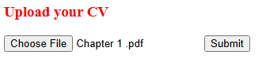

In console
Output of console.log(file)
{
fieldname: 'lju',
originalname: 'Chapter 1 .pdf',
encoding: '7bit',
mimetype: 'application/pdf',
destination: 'upload',
filename: 'lju-file.pdf',
path: 'upload\\lju-file.pdf',
size: 1200577
}
Node mailer

Nodemailer is a module for Node.js applications to allow easy email sending.

Install nodemailer using the following command:
npm install nodemailer
let transporter = nodemailer.createTransport(options[, defaults])
Where
- options – is an object that defines connection data (see below for details)
- defaults – is an object that is going to be merged into every message object. This allows you to specify shared options, for example to set the same from address for every message

General options
- port – is the port to connect to (defaults to 587 if is secure is false or 465 if true)
- host – is the hostname or IP address to connect to (defaults to ‘localhost’)
- auth – defines authentication data

Authentication
If authentication data is not present, the connection is considered authenticated from the start. Otherwise you would need to provide the authentication options object.
auth is the authentication object
- user is the username
- pass is the password for the user if normal login is used
To start sending emails with Nodemailer, all you need to is:
  - Create a transporter object
  - Configure the mailoptions object
  - Deliver a message with sendMail()

The following are the possible fields of an email message:
- from - The email address of the sender. All email addresses can be plain ‘sender@server.com’ or formatted '“Sender Name” sender@server.com', see Address object for details
- to - Comma separated list or an array of recipients email addresses that will appear on the To: field
- cc - Comma separated list or an array of recipients email addresses that will appear on the Cc: field
- bcc - Comma separated list or an array of recipients email addresses that will appear on the Bcc: field
- subject - The subject of the email
- text - The plaintext version of the message
- html - The HTML version of the message
- attachments - An array of attachment objects. Attachments can be used for embedding images as well.

Simple example to send mail using nodemailer.
mailer.js
var nm = require("nodemailer");

var trans = nm.createTransport({
host : "smtp.gmail.com",
port:465,
auth:{
user : "sender@gmail.com",
pass : "App Password"
}
});
var mailoption = {
from:"sender@gmail.com",
to:"receiver1@gmail.com,receiver2@gmail.com ",
subject : "Hello",
text : 'Test mail',
html:'Testing node mailer, <h1>Effect of h1</h1>'
};
trans.sendMail(mailoption,(err,info)=>{
if(err){
console.error(err);
}
console.log(info);
});

gmail >>
manage your google account >>
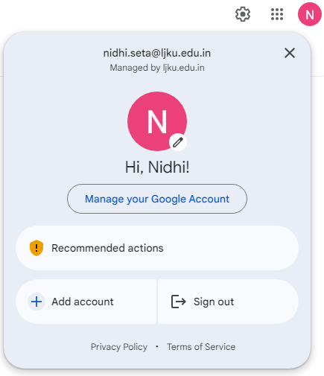

security >>
2 step verification(If set) >>

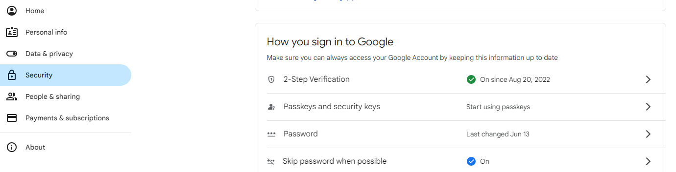

app passwords >>

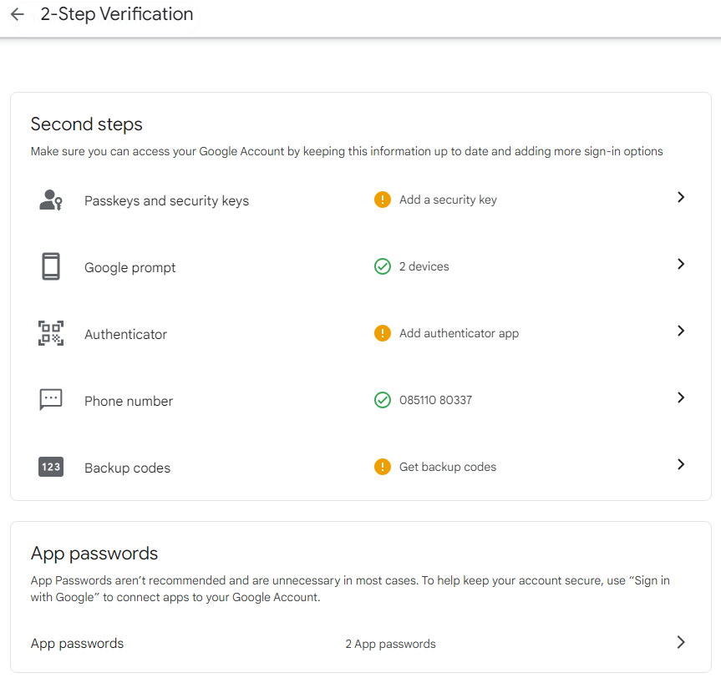

Enter App name and create password >>
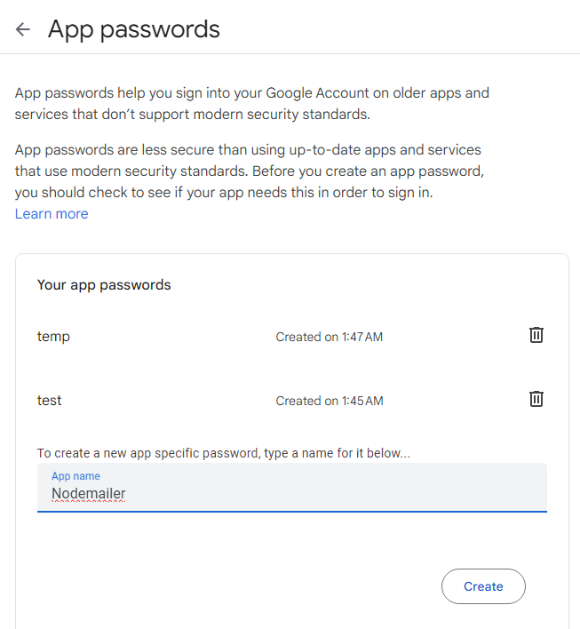

Example
Perform the following tasks as asked:
1) Create a HTML file for response form and this file should be loaded on home(‘/’) page.
•Fields are : Name, Email and Submit button.
2) Once Response is submitted, message “Thank you for your response.” Will be displayed on page ‘/response’ and also send mail to the entered email id with the submitted response.

app.js
const express = require('express');
var nm = require("nodemailer");
const app = express();
// middleware to read form data
app.use(express.urlencoded({ extended: true }));
// serve static files (HTML)
app.use(express.static(__dirname)); // serves index.html automatically
// POST route
app.post('/response', (req, res) => {
const name = req.body.name;
const email = req.body.email;
// transporter
var trans = nm.createTransport({
host: "smtp.gmail.com",
port: 465,
secure: true,
auth: {
user: "sender@gmail.com",
pass: "your_app_password"
}
});
// mail options
var mailoption = {
from: "sender@gmail.com",
to: email,
subject: "Response Received",
text: `Hello ${name}, your response has been received.`,
html: `Hello ${name},<br><br>
<h3 style="color:green;">Thank you for your response.</h3>`
};
// send mail
trans.sendMail(mailoption, (err, info) => {
if (err) {
console.error(err);
return res.send("Error sending email");
}
console.log(info);
res.send("<h2>Thank you for your response.</h2>");
});
});
app.listen(3000, () => {
console.log("Server running on port 3000");
});

index.html
<h2>Response Form</h2>
<form action="/response" method="POST">
Name: <input type="text" name="name" required><br><br>
Email: <input type="email" name="email" required><br><br>
<input type="submit" value="Submit">
</form>

What is EJS?
What is the "E" for? "Embedded?" Could be. How about "Effective," "Elegant," or just "Easy"? EJS is a simple templating language that lets you generate HTML markup with plain JavaScript. No religiousness about how to organize things. No reinvention of iteration and control-flow. It's just plain JavaScript.

Use plain JavaScript
We love JavaScript. It's a totally friendly language. All templating languages grow to be Turing-complete. Just cut out the middle-man, and use JS!

Fast development time
Don't waste time and attention figuring out arcane new syntax because 'elegance' or how to preprocess your data so it will actually render right.

Simple syntax
JavaScript code in simple, straightforward scriptlet tags. Just write JavaScript that emits the HTML you want, and get the job done!

Speedy execution
We all know how fast V8 and the other JavaScript runtimes have gotten. EJS caches the intermediate JS functions for fast execution.

Easy debugging
It's easy to debug EJS errors: your errors are plain JavaScript exceptions, with template line-numbers included.

Active development
EJS has a large community of active users, and the library is under active development. We're happy to answer your questions or give you help.
EJS lets you write HTML + JavaScript together and render dynamic pages using Express.
Installation
npm install ejs

Example
const express = require('express');
const app = express();
// set EJS
app.set('view engine', 'ejs');
app.get('/', (req, res) => {
res.render('first');
});
app.listen(3000);

EJS TAGS
Tag | Description | Example
<% %> | Scriptlet (logic only, no output) | <% if(x>10){ %>
<%= %> | Output (HTML escaped) | <%= name %>
<%- %> | Output (unescaped HTML) | <%- "<b>Hi</b>" %>
<%# %> | Comment (not executed) | <%# comment %>
<%% | Print literal <% | <%% Hello %>

<% %> → Scriptlet Tag (Logic Only)

Purpose:
Used for control flow (if, loop, variables)
Does NOT print anything

Example:
<% let marks = 60; %>
<% if (marks >= 40) { %>
<p>Pass</p>
<% } else { %>
<p>Fail</p>
<% } %>

Output:
Pass

2. <%= %> → Output (HTML Escaped)

Purpose:
Displays data safely (prevents HTML injection)

Example:
<% let name = "<b>Rahul</b>"; %>
<p><%= name %></p>

Output:
<b>Rahul</b> (shown as text, NOT bold)
Tags are escaped → safe

3. <%- %> → Output (Unescaped HTML)

Purpose:
Displays raw HTML (renders tags)

Example:
<% let name = "<b>Rahul</b>"; %>
<p><%- name %></p>

Output:
Rahul (in bold)

Note:
<%= %> → shows text only (safe)
HTML tags are NOT applied
<%- %> → shows real HTML
HTML tags ARE applied

4. <%# %> → Comment Tag

Purpose:
Add comments that are not visible in browser
Example:
<%# This is a comment %>
<p>Hello</p>

Output:
Hello

5. <%% → Print <% Literally

Purpose:
Used when you want to show EJS syntax as text

Example:
<p><%% This is EJS %></p>

Output:
<% This is EJS %>

Example:

Structure
project/
│
├── app.js
└── views/
└── first.ejs

app.js
const express = require('express');
const app = express();
app.set('view engine', 'ejs');
app.get('/', (req, res) => {
res.render('first', { name: "Rahul" });
});
app.listen(3000);

views/first.ejs
<h1>Hello <%= name %></h1>

If you don’t want to use a views folder, you just need to tell Express where your EJS files are located.

Folder structure
project/
│
├── app.js
├── first.ejs (no views folder needed)
You can change the views directory like this:
const express = require('express');
const path = require('path');
const app = express();
app.set('view engine', 'ejs');
// set custom folder (same directory or any folder you want)
app.set('views', path.join(__dirname));
app.get('/', (req, res) => {
res.render('first', { name: "Rahul" });
});
app.listen(3000);

FORM HANDLING WITH EJS + EXPRESS
Example
Develop a web application using Express and EJS that allows a user to enter a student’s name and marks through a form. After submission, the application should display the entered details and determine the result: if the marks are 40 or above, show “Pass” in green color; otherwise, show “Fail” in red color.

Create Form (form.ejs)
<h2>Student Form</h2>
<form action="/submit" method="post">
Name: <input type="text" name="name"><br><br>
Marks: <input type="number" name="marks"><br><br>
<input type="submit" value="Submit">
</form>

Server Code(my.js)
const express = require('express');
const app = express();
app.set('view engine', 'ejs');
// to read form data
app.use(express.urlencoded({ extended: true }));
// show form
app.get('/', (req, res) => {
res.render('form');
});
// handle form
app.post('/submit', (req, res) => {
const name = req.body.name;
const marks = req.body.marks;
res.render('result', { name, marks });
});
app.listen(3000);

Result Page (result.ejs)

<h2>Name: <%= name %></h2>
<h2>Marks: <%= marks %></h2>
<% if (marks >= 40) { %>
<p style="color:green">Pass</p>
<% } else { %>
<p style="color:red">Fail</p>
<% } %>
Example
Write an Express.js application to perform the following tasks:
1) Create an EJS file named contact.ejs that displays a heading "Contact Form" and contains a form with:
-Text input for Name
-Email input for Email
-Submit button
2) Render this EJS file on the /contact route.
3) Handle form submission using the POST method on the /submit route.
4) After form submission, display a message on the browser in the format:
"Thank you (Name), we have received your email (Email)." Through ejs file.

Folder Structure
project/
│
├── app.js
└── views/
└── contact.ejs
└── result.ejs

contact.ejs
<h2>Contact Form</h2>
<form action="/submit" method="POST">
Name: <input type="text" name="name" required><br><br>
Email: <input type="email" name="email" required><br><br>
<input type="submit" value="Submit">
</form>

app.js (Express Server)
const express = require('express');
const app = express();
// set EJS
app.set('view engine', 'ejs');
// middleware to read form data
app.use(express.urlencoded({ extended: true }));
// render contact form
app.get('/contact', (req, res) => {
res.render('contact');
});
// handle form submission
app.post('/submit', (req, res) => {
const name = req.body.name;
const email = req.body.email;
// render result page with data
res.render('result', { name, email });
});
app.listen(3000, () => {
console.log("Server running on port 3000");
});

result.ejs
<h2>
Thank you <%= name %>, we have received your email <%= email %>.
</h2>

Example
Develop a web application using Express and EJS to accept marks of four tests (T1, T2, T3, T4), each out of 25, through a form using the POST method. After submission, display all entered marks in a tabular format along with the total marks, and determine the result: if the total is 35 or more, display “Pass” in green color; otherwise, display “Fail” in red color. (result also by ejs file)
project/
│
├── app.js
└── views/
├── form.ejs
└── result.ejs

form.ejs
<h2>Enter Marks (Each out of 25)</h2>
<form action="/submit" method="POST">
T1: <input type="number" name="t1" required><br><br>
T2: <input type="number" name="t2" required><br><br>
T3: <input type="number" name="t3" required><br><br>
T4: <input type="number" name="t4" required><br><br>
<input type="submit" value="Submit">
</form>

result.ejs
<h2>Marks Details</h2>
<table border="1" cellpadding="10">
<tr>
<th>T1</th>
<th>T2</th>
<th>T3</th>
<th>T4</th>
</tr>
<tr>
<td><%= t1 %></td>
<td><%= t2 %></td>
<td><%= t3 %></td>
<td><%= t4 %></td>
</tr>
</table>
<br>
<h2>Total: <%= total %></h2>
<% if (total >= 35) { %>
<h3 style="color:green;">Pass</h3>
<% } else { %>
<h3 style="color:red;">Fail</h3>
<% } %>

app.js
const express = require('express');
const app = express();
app.set('view engine', 'ejs');
// middleware for POST data
app.use(express.urlencoded({ extended: true }));
// show form
app.get('/', (req, res) => {
res.render('form');
});
// handle form
app.post('/submit', (req, res) => {
const t1 = parseInt(req.body.t1);
const t2 = parseInt(req.body.t2);
const t3 = parseInt(req.body.t3);
const t4 = parseInt(req.body.t4);
const total = t1 + t2 + t3 + t4;
res.render('result', { t1, t2, t3, t4, total });
});
app.listen(3000);

Example
Create a basic web application using Node.js, Express.js, and EJS to display user information on a webpage.
The application should:
- Configure EJS as the view engine
- Create a route /users in the server
- Inside this route, define a list of users (each user should have name, email, and age)
- Pass this user data from the server to an EJS file
- Use EJS to loop through the data and display it in an HTML table
my.js
const express = require('express');
const app = express();

app.set('view engine', 'ejs');

// sample JSON data
app.get('/users', (req, res) => {
const users = [
{ name: "Rahul", email: "rahul@gmail.com", age: 22 },
{ name: "Priya", email: "priya@gmail.com", age: 25 },
{ name: "Amit", email: "amit@gmail.com", age: 30 }
];

res.render('my', { users });
});

app.listen(3000, () => {
console.log("Server running on port 3000");
});

my.ejs
<h2>User List</h2>

<table border="1" cellpadding="10">
<tr>
<th>Name</th>
<th>Email</th>
<th>Age</th>
</tr>

<% for(let u of users) { %>
<tr>
<td><%= u.name %></td>
<td><%= u.email %></td>
<td><%= u.age %></td>
</tr>
<% } %>
</table>
